STANDARD FORMAT OF “LEHENGA DESCRIPTION”


For Online Selling Products
Design Name: TAPOVAN
Product Colours NO.: A1
.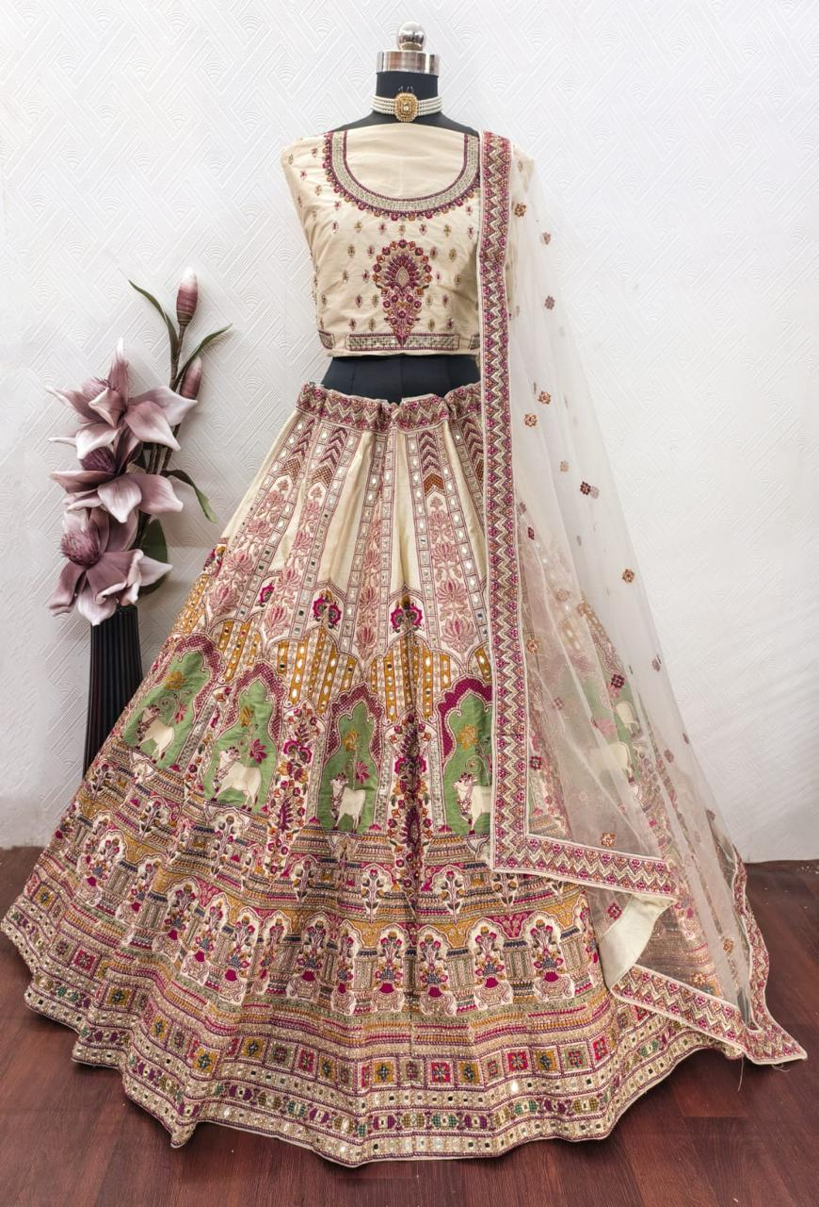
Particulars | Details
Lehenga Fabric | Italian Silk
Blouse Fabric | Italian Silk
Dupatta Fabric | Net
Work Type | Jari, Jarkan - embroidery
Colour | Chiku
Pattern | Bridal Designer Lehenga
Stitching Type | Semi-Stitched (Can be customized up to 44")
Occasion | Wedding, Reception, Engagement & Festive Wear
Fit Type | Regular Fit
Care Instructions | Dry Clean Only
Package Contents | 1 Lehenga, 1 Blouse Piece, 1 Dupatta

KEY HIGHLIGHTS
- Premium-quality Italian Silk fabric for an elegant look
- Detailed Jari & Jarkan embroidery with fine craftsmanship
- Comes with matching blouse and net dupatta
- Ideal for weddings, receptions, and festive occasions
- Semi-stitched design for easy customization (up to size 44)
- Ensures regular fit and long-duration comfort
- Stylish blend of traditional and modern design
- Lightweight and comfortable for long wear
- High-quality finish for a luxurious bridal appearance

